Georgia State Parks and Historic Sites
Weekend Summary
04.13.2020

Storm update:
- Severe weather on Sunday night left 3 sites in north Georgia without power as well as F.D. Roosevelt, Kolomoki, Florence Marina, Providence Canyon and Victoria Bryant.
- DNR Debris Teams were deployed Monday morning to Tugaloo with 20-25 trees down. Tugaloo is currently closed due to trees being down.
- Jarrell Plantation has several trees on two historic structures and minor damage to the Visitor Center.
- F.D. Roosevelt has one tree on cottage 4 causing roof damage.
- Providence Canyon has trees down on the pioneer campsite 2 road.
- Florence Marina has a large tree down but no damage.
- Mistletoe and Victoria Bryant had a couple of trees down throughout the park.
- Hamburg experienced the most down trees with approximately 12-15. The local EMC for Hamburg is assisting with the removal of several trees on power lines.
Crowds:
- Some sites are up 25-30% in visitation over last year and most sites in north Georgia had high day use traffic on Saturday. Providence Canyon, Red Top, Sweetwater, Tallulah Gorge and Cloudland Canyon closed day use areas on Saturday when parking reached capacity. Other sites with heavy day use traffic include General Coffee, FD Roosevelt and High Falls. LED had to address parking on Mount Vernon Road at Sweetwater Creek, as well as road shoulders at Red Top. LED had to assist with one car accident at Sweetwater which occurred due to traffic coming in and out of the park. People also parked in subdivisions and walked into the park when Sweetwater filled to capacity and closed incoming traffic.
- Boat ramp activity is as follows:
  - Fort McAllister boat ramp near capacity and many day use visitors on Saturday.
  - Florence Marina closed the boat ramp Friday from 7:30 am - 12:00 pm due to the 30-boat limit and again on Saturday from 7:30 am - 4:15 pm. A fishing tournament was held Saturday and a group of 14 individuals were addressed by Park Rangers to comply with Social Distancing/10 or less people. They complied and left the area.
  - Richard B. Russell, Elijah Clark, and Mistletoe experienced less boating activity than the prior weekend. Richard B. Russell did have to close the mega ramp down from 12:00 PM-1:00 PM on Saturday due to boat trailer capacity limits.
- Golf Course activity:
  - The Creek Golf Course at Hard Labor Creek did have one group of golfers gathered over 10 that the staff had to speak to outside of the clubhouse.
  - Highland Walk (HWGC) at VBSP saw a significant visitation increase for this past week and on Saturday. Over the course of this past week, HWGC has seen 485 paid rounds, which is a 20% increase from last year’s opening week in April.
  - Laura S. Walker and Gordonia golf courses are having a hard time providing carts, especially putting them out in the morning and back in the evening due to staffing shortages.

Staffing issues:
- As of today, the Division as a whole has 139 part-time and full-time staff out due to COVID-19 related reasons. A total of 32 Camp Host Units (approximately 64 people) have left due to COVID-19 and 12 units have been replaced.
- The only staff at George L. Smith reporting to work is the Park Manager. Hosts are helping with trash removal but not cleaning comfort stations. Staff from Stephen C. Foster supported over the weekend.
- Sweetwater Creek and Red Top received assistance from Pickett’s Mill and Etowah to assist with the large volume of guests over this weekend.

Positives
- Sites received masks, hand sanitizer and gloves.
- A local church at Crooked River delivered Easter lilies to campers, hosts, and staff over the weekend.
- LED is making regular visits to the parks with many reporting daily or multiple patrols each day.
- Website traffic 4/6-4/12
  - /Alerts - 47,041 views. YTD- 186,000
  - /eRanger- 565 views. YTD- 2,371
  - /Reservations - up 11% YoY
  - Total pageviews - up 20% YoY
- eRanger Facebook reach/views
  - 4/6-4/12 103,600
  - YTD 353,000

Challenges
- High day use traffic at some sites has been challenging.
- At Cloudland the local press and County Commissioner are reporting the park is to be closed indefinitely. This has been confusing for staff and customers, especially campers and cottage guests with reservations at the park.
- Laura S. Walker had to call LED to deal with jet skis on the lake, which is currently closed for anything except trolling motors.
- Crooked River had to call LED regarding a camper chopping down trees, dogs off leash, and a number of other issues.
- Crooked River had to re-tape the playgrounds at least three times this weekend due to visitors disregarding the playground closure. This is occurring at several sites.
- Groups: LED broke up a few groups in various parks including Sweetwater Creek and F.D. Roosevelt. Fort Yargo staff had to break up one group over 10 in the day-use area on Saturday. The Mistletoe staff had to speak to one family about having chairs at the beach on Saturday. Laura S. Walker had guests on the beach not observing social distancing.
- One arrest by LED occurred at Tallulah Gorge.
- When Red Top closed due to capacity, some vehicles stopped in the road and drivers exited their vehicles to attempt to talk to staff. While doing this, other drivers were crossing over the other side of the road to u-turn or drove off road shoulders creating a dangerous situation.
- FDR had large amounts of trash on the grounds including masks, gloves, and water bottles. Trash receptacles were available but not used. An unregistered visitor occupied a backcountry camping site and refused to leave when approached by registered visitor. LED game wardens have the occupant’s vehicle tag number and phone number to make contact with later.

Media
- https://www.timesfreepress.com/news/local/story/2020/apr/11/cloudland-canyon-state-park-shut-down/520459/

- https://wdef.com/2020/04/04/cloudland-canyon-state-park-hikers-speak-news-12/

- https://wdef.com/2020/04/06/dade-officials-happier-cloudland-canyon-crowds/

COVID19 Financial-Occupancy Impact thru April 12th
Weekend Occupancy:
Past Weekend:
Overall, we saw a 17% drop in occupancy for all reservables. Last week it was a 27% decrease overall. Cottage occupancy dropped 43%, while yurts saw an 18% decrease and camping dropped 13%.
PAST WEEKEND | April 12/13 | April 10/11
OCCUPANCY | FY19 | FY20 | Difference
All Reservables | 75% | 58% | -17%
Camping | 83% | 70% | -13%
Cottage | 85% | 42% | -43%
Yurt | 95% | 77% | -18%
Upcoming Weekend:
If we look at the upcoming weekend, we are currently at a 17% decrease. (Last week we were seeing a 19% decrease at this point.) Camping is at a decrease of 9%; Cottages at 62% and Yurts are the same.

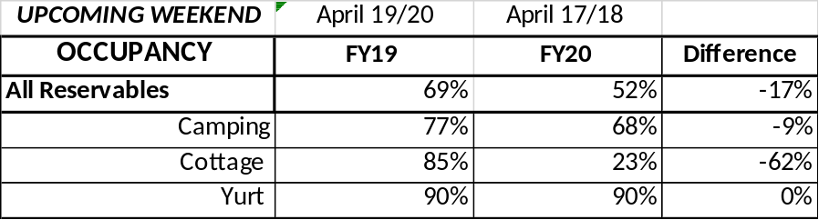
Revenue:
For the month of March through April 12th, we have seen a decrease in revenue of 43% or a loss of $2.1 Million.
ParkPass has decreased 12% during this timeframe, and for the second week, we are continuing to see a substantial drop, with it decreasing 35% this past week. Although significant, customers are beginning to get familiar with and using the QR code.
Golf is now at a 0% change from the previous FY. It decreased 23% this past week, which is the first week we have seen a reduction in golf since this all began.
For overnight accommodations – camping revenue is at a 15% reduction, it was at 26% last week; cottages are now at a 66% loss for March/April; yurts at a 50% loss (saw an increase in yurt revenue this past week).
We are seeing the revenue improve over last week due to several reasons:
- Camping and yurt occupancy didn’t drop as much as it has in the previous weeks.
- We are now collecting all revenues at the time of booking, no longer just a one-night deposit. This change is going to assist us during this time but will make it difficult to project future revenues.
- The number of cancellations is starting to significantly slow down. Although we do need to keep in mind, that for future refunds, we will be refunding the revenue for the entire stay, rather than just a one-night deposit.
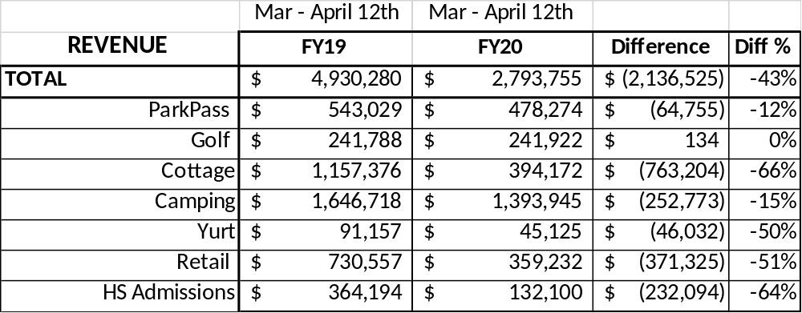
Cancellations/Refunds:
Through this Monday morning, April 13, we have had 18,000 cancellations, including $1.6 Million in actual refunds and a loss of future revenue of $5,800,000.
This is 2,000 more than last Monday, when we were at 16,000 cancellations. So, we are starting to see a significant drop in the number of cancellations. We were trending at about 4,000 – 5,000 cancellations a week.
Last year during this same time period, we had 4,000 cancellations, including $207,000 in actual refunds and a loss of future revenue of $960,000.
So, total cancellations have increased over 14,000 or 350% and the amount of refunds have increased $1,393,000.

